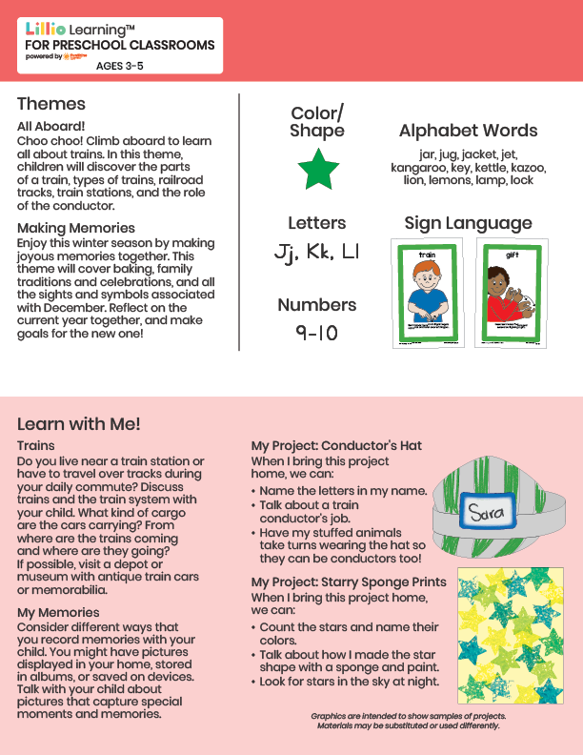
Add Your Name/Logo Here
December 2025
Newsletter

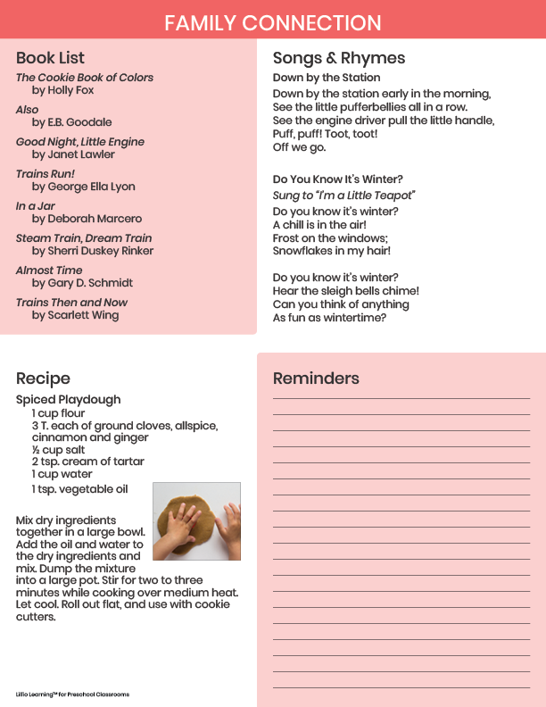

Add Notes

